The Woman who is mentoring me works in the Heliophysics department at NASA.

**Monday**

Mapping the dark Aurora lights using MATLAB

**Tuesday**

Mapping the dark Aurora lights using MATLAB

**Wednesday**

Mapping the dark Aurora lights using MATLAB

Reliazed it was doing to much to slowly and researched for a different route to faster ananlyze the video

Recursive Particle Tracking

<https://www.youtube.com/watch?v=Y_xlB94z8c0>

**Thursday**

Mapping the dark Aurora lights using MATLAB

**Friday**

Mapping the dark Aurora lights using MATLAB

**Project 1 -Talk Machines Mechanisms**

**For the next couple week they will be building a couple of pieces need in order for us to re build the machine. All that was done this week was unboxing and making sure the materials order where there.**

**Looked at a few more math videos but the extent of my knowledge can alone go so far from just videos. Decide to try an finish Project 2 and focus on getting out to anther lab too practice LaView.**

**Project 2 - MATLAB Aurora Lights**

**First to days Monday and Tuesday where spent of improving and modifying the code I had. It seem to be working and finding the correct areas with same type of color pattern. I ended up setting the threshold to a smaller interval and got a smaller number of match to appears which is what I wanted. The only problem is that there are about 1000 different frames within the 20 minute video and one photo take s approximately 25 minutes to process results that are not as accurate as the should be.**

**Because of this started looking for new methods Wednesday. The cropping method works kind of, so it set for later but it kind of defeats the purpose of efficacy at this point.**

**I ended up doing some research for different methods. I found the Recursive Particle Tracking method. It’s a method used in MatLab, that take the video and look for all the lightest parts. You set a threshold and anything above that threshold is labeled as white and everything else is labeled as white.**

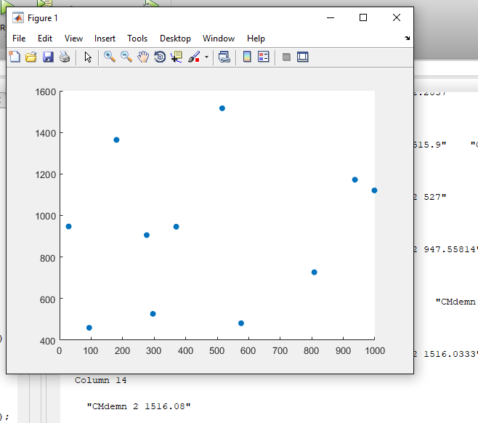

**(Above is mapping out where the stars are on the graph which is not the goal.)**

**But the real goal is to plot the darkest point, thereby making a cluster of the dots in one area that correspond to the**

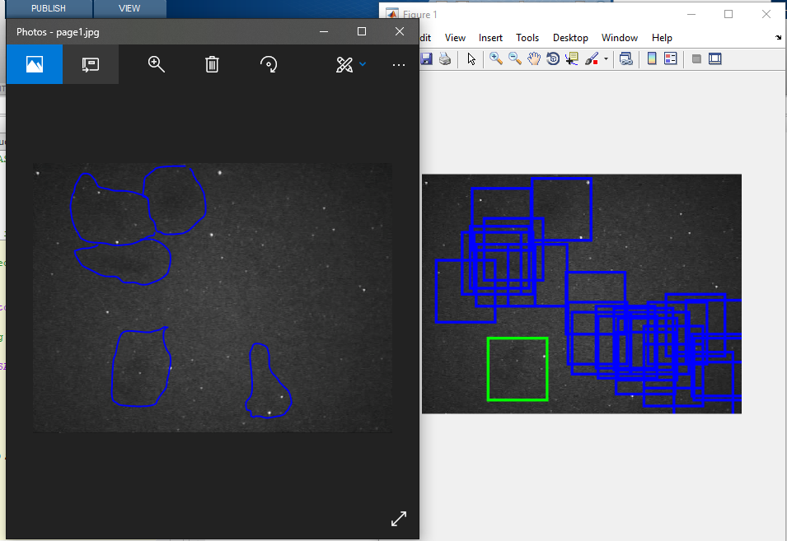

**Above shows what the code is doin now and it is pretty close to the results I am looking for. Just takes to long at this time**